**Project Name: women’s accessories**

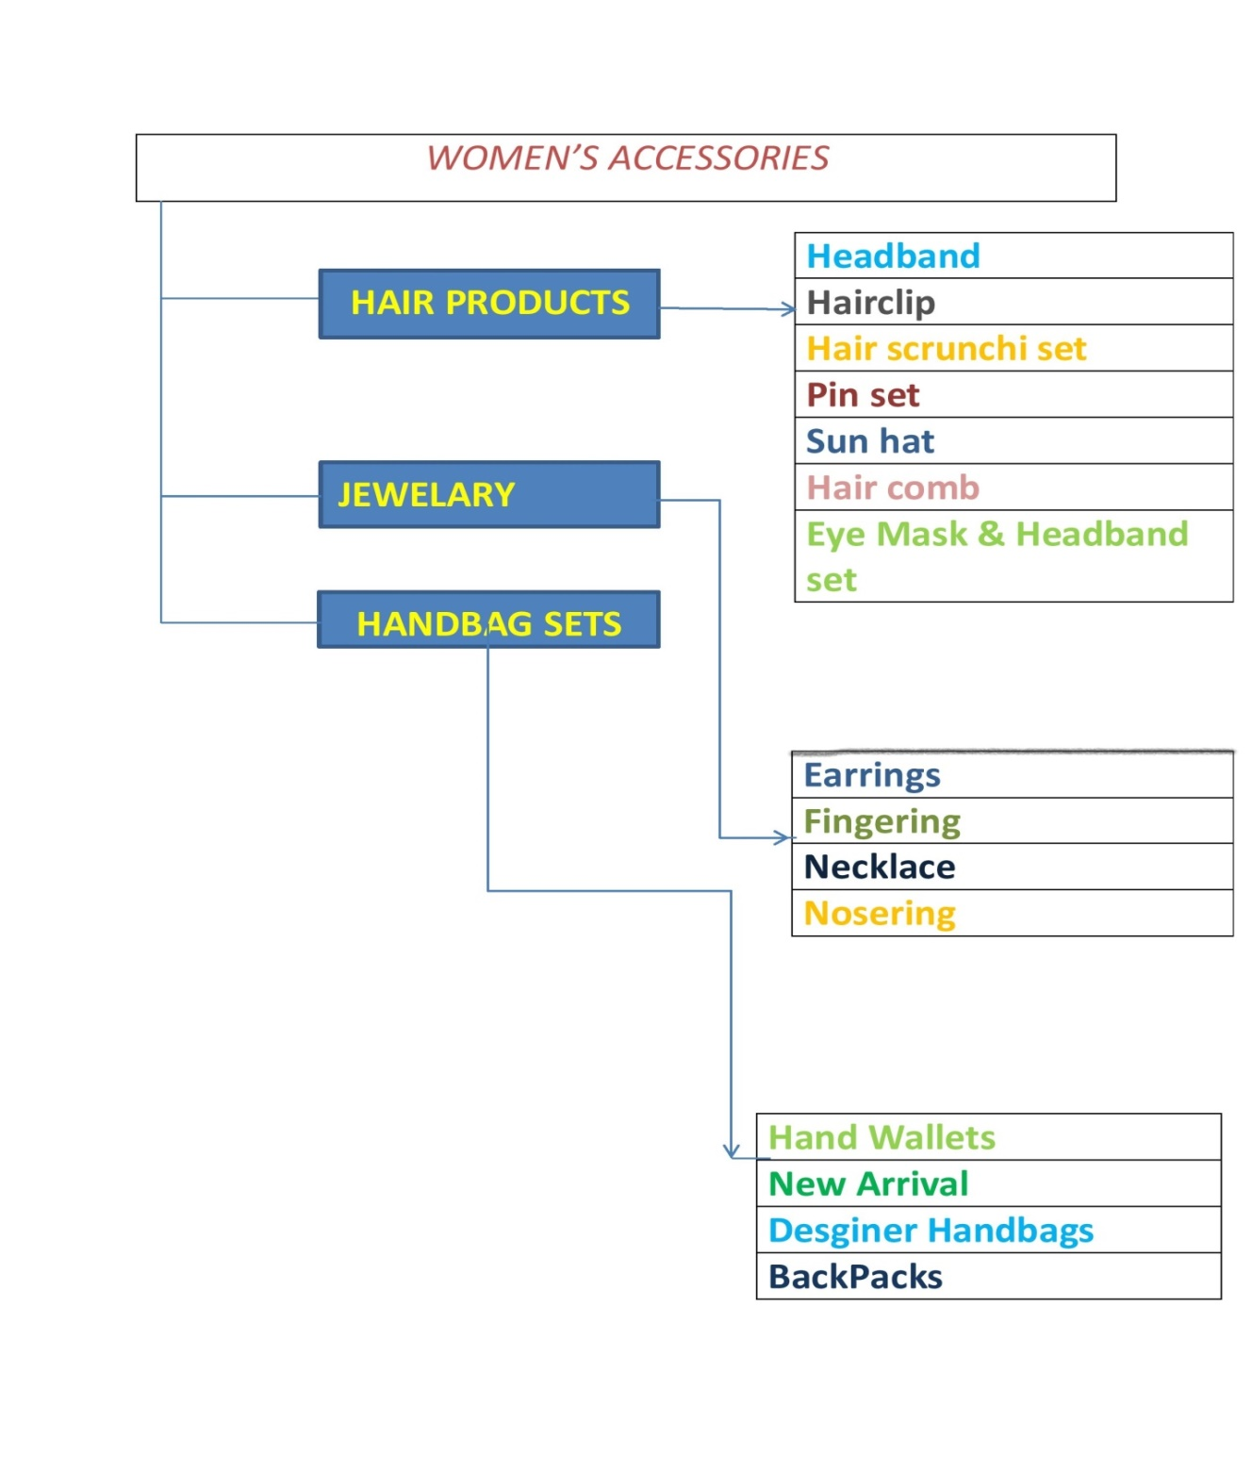

I have created page on **women’s accessories.**

**Women’s accessories login page**

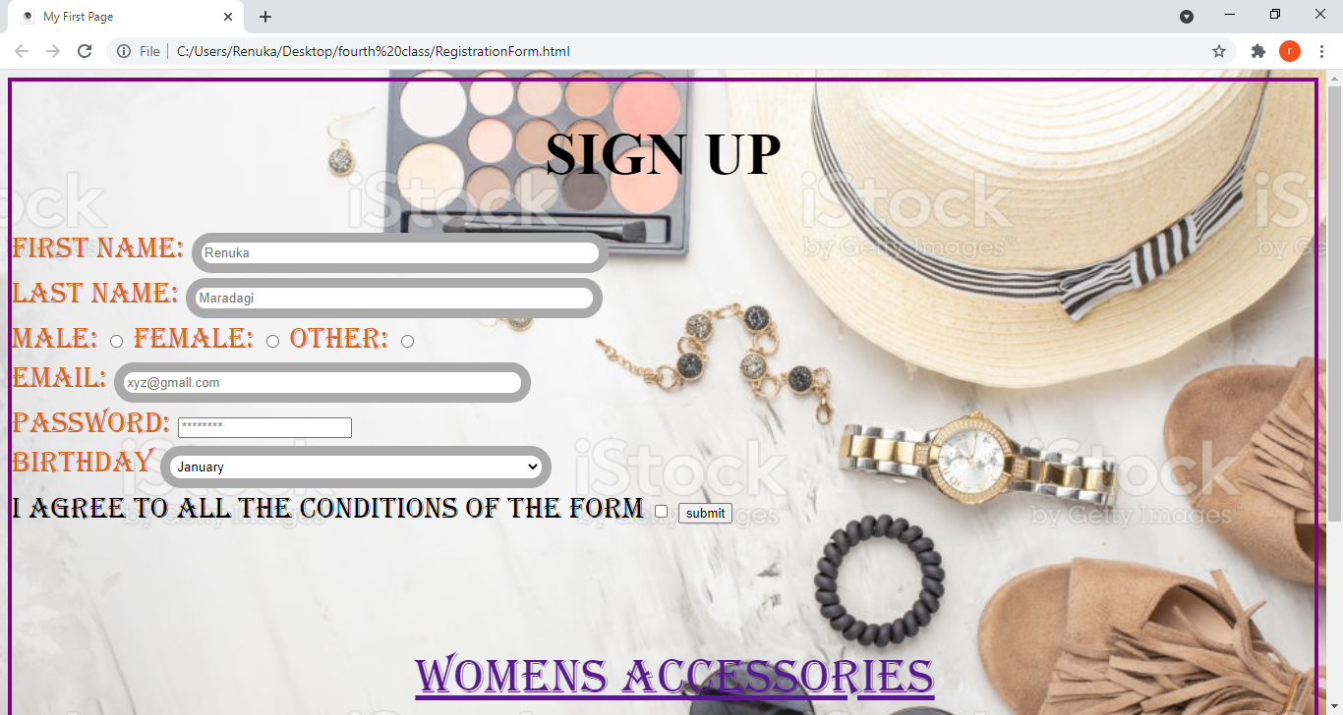

**Second project Home page**

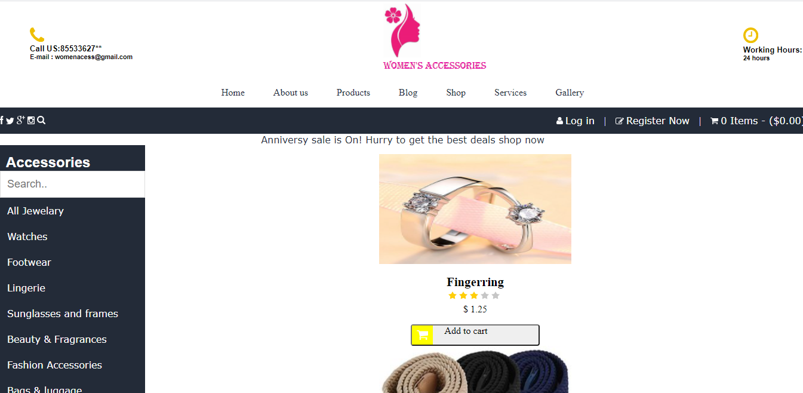

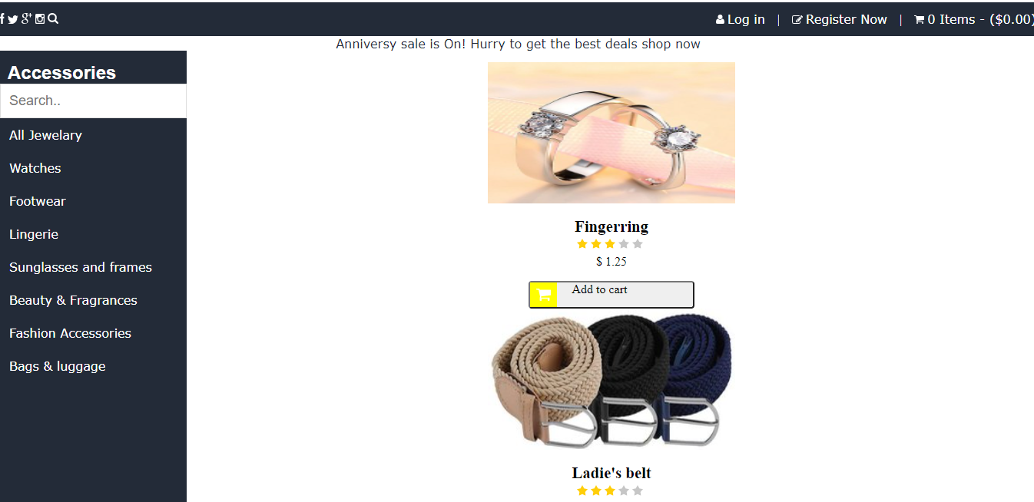

**Overview**

Women’s accessories are an Indian fashion shop. We believe that if you look good you can do well for others around you. Cents of style brings you a wide range of trendy shoes beautiful scarves and statement-making jewelry, all at affordable prices to make them accessible to you.

**Goals**

* Registration/Sign Up
* Login page/Sign In
* Payment page
* Return and exchange
* Logout page

**History**

In the last three decades of the eighteenth century, other, more informal styles became fashionable for daywear and the hair accessory was increasingly worn.

**Technologies used in Women’s accessories**

Front-End:

* HTML
* CSS
* Bootstrap
* React

Dynamic:

* Javascript
* Ci/cd with AWS
* Login and Logout

Database:

* Mango db
* Json Data
* Login and Logout

Code Compilers:

* Visual studio code
* Git bash
* Git hub
* Node js.

Renuka Maradagi

(Edureka Presents)